**LA1780 Assignment 1 – A Library**

- Taha Adeel Mohammed

CS20BTECH11052

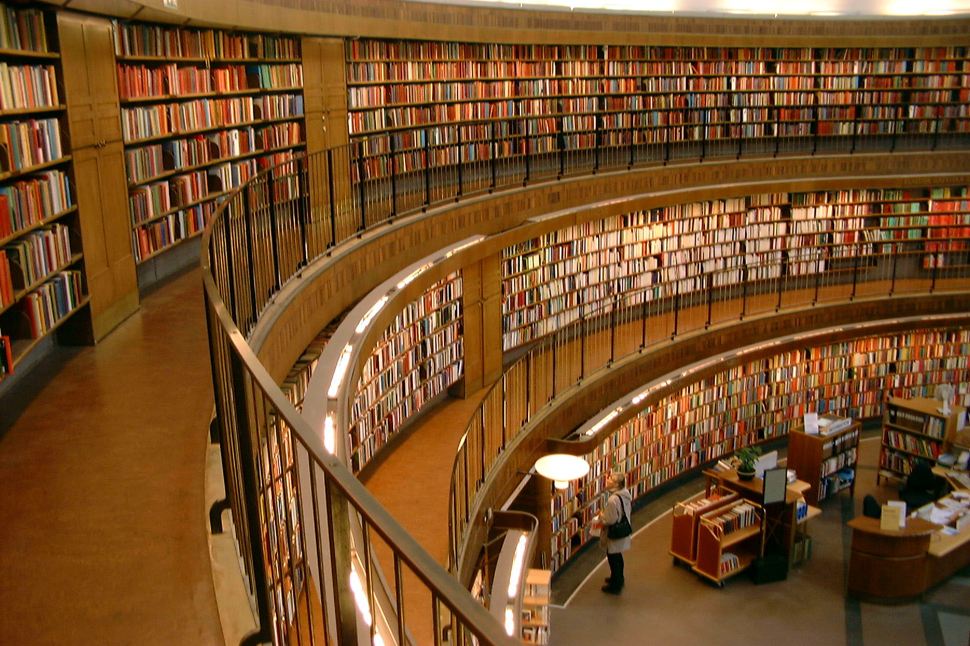  
The picture I have choosen for the assignment is a photo of the Stockholm Public Library by Marcus Hansson. Libraries, with their numerous shelves, and countless books, never ceased to fascinate me. They can be considered as a vast record of human experiences gathered over time. Libraries are one of the few places that people of all ages and backgrounds can enjoy. They contain a very vast and diverse genre of books, ranging from history, political science, fiction, autobiographies, philosophy, sciences, magazines to comics and self-help books. The countless authors’ thoughts are frozen in time in their works, which we experience as we read through the books. Or they may contain time-invarient facts and laws governing the universe, which humanity discovered over generations. Libraries are a magical place with respect to time. We can percieve time very differently in libraries, whether it is getting lost in a story book for hours, or cramming formulae the night before an exam, or rushing to meet deadlines while working in the library. We may mentally travel back in time while reading history accounts, or medieval fantasies, or be transported into a utopian/destopian future while reading science fiction novels. Libraries give us access to vast amounts of knowledge, hence helping us increase our estime, or insightful tips from experts in different fields, guiding us about their techniques, or allow us to ponder over ethics with philosophers of the past, or in fictional settings with different ethical norms. While the stories in books in the libary are finished and unchanging with time, reading them subtly shapes us and our personalities, making us who we are and guiding us in the future.